**Master – Thesis 11.03.2025**

## **Data analysis of PIV measurements and CFD simulations on the mixing process in biogas plants**

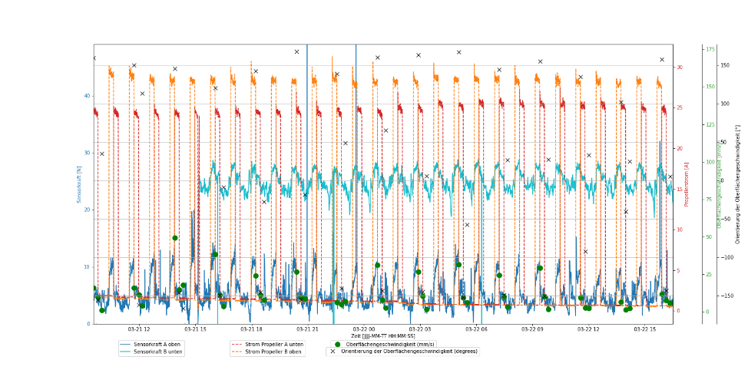#Description

# Import necessary libraries

# (hypothetical for simulation and data analysis)

import numpy as np

import matplotlib.pyplot as plt

**# Task Definition**

def literature_research():

"""Conduct a literature review on PIV measurements and CFD validation methods."""

print("Step 1: Reviewing relevant literature...")

def define_target_parameters():

"""Define key target parameters for evaluating mixing efficiency based on PIV and CFD data."""

parameters = ["Velocity distribution", "Turbulence intensity", "Mixing time"]

print("Defined Target Parameters:", parameters)

return parameters

def compare_piv_cfd_data(parameters):

"""Compare PIV measurements from real plant and model fermenter with existing CFD results."""

datasets = ["Real Plant PIV", "Model Fermenter PIV", "Model Fermenter CFD"]

results = {dataset: {param: np.random.rand() for param in parameters} for dataset in datasets}

print("Comparison of PIV and CFD data:", results)

return results

def analyze_geometry_comparison(parameters):

"""Use existing CFD data to compare different geometries based on defined target parameters."""

geometries = ["Real Plant", "Model Fermenter", "CFD Model"]

results = {geo: {param: np.random.rand() for param in parameters} for geo in geometries}

print("Comparison of geometries based on target parameters:", results)

return results

def derive_sensor_positioning():

"""Analyze CFD and PIV data to derive positioning criteria for a mixing quality sensor system."""

print("Deriving optimal sensor positioning criteria based on data analysis...")

# Placeholder for logic to determine best sensor placement

def improve_experiments():

"""Suggest improvements for future PIV experiments to enhance data quality."""

print("Providing recommendations for experimental improvements...")

# Placeholder for improvement suggestions

# Execution Order

if __name__ == "__main__":

literature_research()

params = define_target_parameters()

results_piv_cfd = compare_piv_cfd_data(params)

results_geometry = analyze_geometry_comparison(params)

derive_sensor_positioning()

improve_experiments()

**# Thesis Metadata**

thesis = {

"Title": "Data analysis of PIV measurements and CFD simulations on the mixing process in biogas plants",

"Supervisor": "Bernhard Huber",

"Institute": "Chair of Regenerative Energy Systems, TUM",

"Location": "Schulgasse 16, 94315 Straubing, Room 0.A10",

"Contact": {

"Phone": "+49 (0) 9421 187-114",

"Email": "b.huber@tum.de"

},

"Earliest Start": "2025-04-01"

}

**#Requirements**

# Basic knowledge of Ansys Fluent

# Advanced programming skills in Python and Matlab

# If you think you are the right candidate to solve this task please contact me.